Use a Debugger, disassemble the file, we get

#### 

it require a key in heximal format number, then compare it with ‘FLAG’ if equal, we get the real FLAG (jump to show_flag)

in show_flag

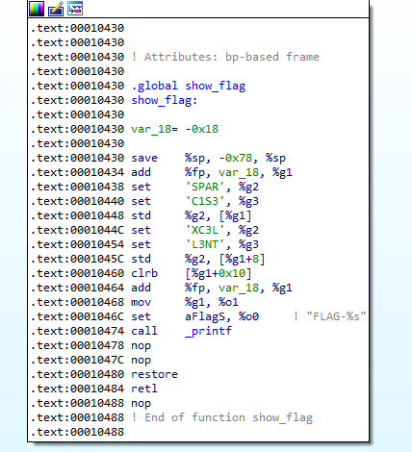

it’ just concates some string

-> FLAG-SPARCIS3XC3LL3NT